**LAB ASSIGNMENT #3**

**(a)**

**STATEMENT:** WRITE A PROGRAM TO INSERT TWO ELEMENTS IN GIVEN ARRAY.

**ALGORITHM:**

Step-1: Start

Step-2: Declare integer a[5]={1,2,3,4,5}, b[7], j=0,x and y.

Step-3: Print the array a[5].

Step-4: Input two elements to be inserted.

Step-5: Print the new array b[7].

Step-6: End

**SOURCE CODE:**

#include<stdio.h>

#include<conio.h>

void main()

{

clrscr();

int a[5]={1,2,3,4,5};

int b[7];

int i,j=0,x,y;

printf("\n Given list of array is: ");

for(i=0;i<5;i++)

printf("%d \t",a[i]);

printf("\n Enter two element to be inserted after third position the above array: ");

scanf("%d",&x);

scanf("%d",&y);

for(i=0;i<5;i++)

{

b[j]=a[i];

j++;

if(i==2)

{

b[j]=x;

j++;

b[j]=y;

j++;

}

}

printf("\n The new array is: \n");

for(i=0;i<7;i++)

{

printf("%d \t",b[i]);

}

getch();

}

**OUTPUT:**

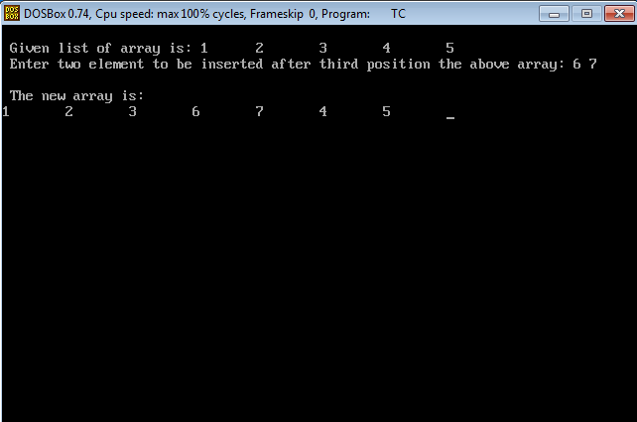

**CONCLUSION:** Hence, the program was successful, and two elements were inserted in given array.

**(b)**

**STATEMENT:** WRITE A PROGRAM TO MERGE TWO GIVEN ARRAY IN ONE ARRAY.

**ALGORITHM:**

Step-1: Start

Step-2: Declare integer a[5]={0,1,2,3,4}, b[5]={5,6,7,8,9} and c[10].

Step-3: Declare integer i and j=0.

Step-4: Print arrays a[i] and b[i].

Step-5: Combine the arrays a[i] and b[i].

Step-6: Print the new array i.e. c[i]

Step-7: End

**SOURCE CODE:**

#include<stdio.h>

#include<conio.h>

void main()

{

clrscr();

int a[5]={0,1,2,3,4};

int b[5]={5,6,7,8,9};

int c[10];

int i,j=0;

printf("\n Given list of array A is: ");

for(i=0;i<5;i++)

printf("\t %d",a[i]);

printf("\nGiven list of array B is: ");

for(i=0;i<5;i++)

printf("\t %d",b[i]);

for(i=0;i<5;i++)

{

c[j]=a[i];

j++;

}

for(i=0;i<5;i++)

{

c[j]=b[i];

j++;

}

printf("\n\n\n The new array is: \n");

for(i=0;i<10;i++)

{

printf("%d \t",c[i]);

}

getch();

}

**OUTPUT:**

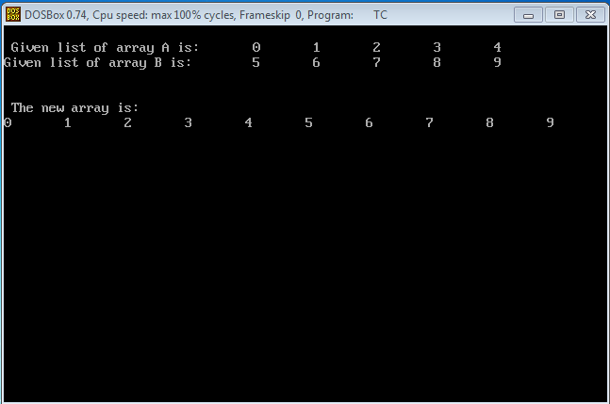

**CONCLUSION:** Hence, the program was successful, and two given array were merged in one array.

**(c)**

**STATEMENT:** WRITE A PROGRAM TO FIND THE SUM OF PRIME NUMBER FROM 1 TO 100 USING ARRAY AND FUNCTON.

**ALGORITHM:**

Step-1: Start

Step-2: Declare integer num, i, count and sum=0.

Step-3: if num is less than or equals to 100,

Then, go to step-4.

Else,

go to step-8

Step-4: Declare count=0

Step-5: If i<=num and num%i=0

Then, increase count by 1 and break.

Step-6: If count=0 and num is not equals to 1

Then, use the formula; sum=sum+num.

Step-7: Print the sum

Step-8: End

**SOURCE CODE:**

#include<stdio.h>

#include<conio.h>

int main()

{

clrscr();

int num,i,count,sum=0;

for(num=1;num<=100;num++)

{

count=0;

for(i=2;i<=num/2;i++)

{

if(num%i==0)

{

count++;

break;

}

}

if(count==0&&num!=1)

sum=sum+num;

}

printf("Sum of prime numbers from 1 to 100 is: %d",sum);

getch();

return 0;

}

**OUTPUT:**

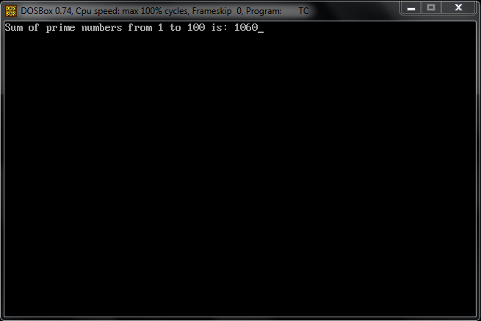

**CONCLUSION:** Hence, the program was successful, and the sum of prime number from 1 to 100 was found using array and function.